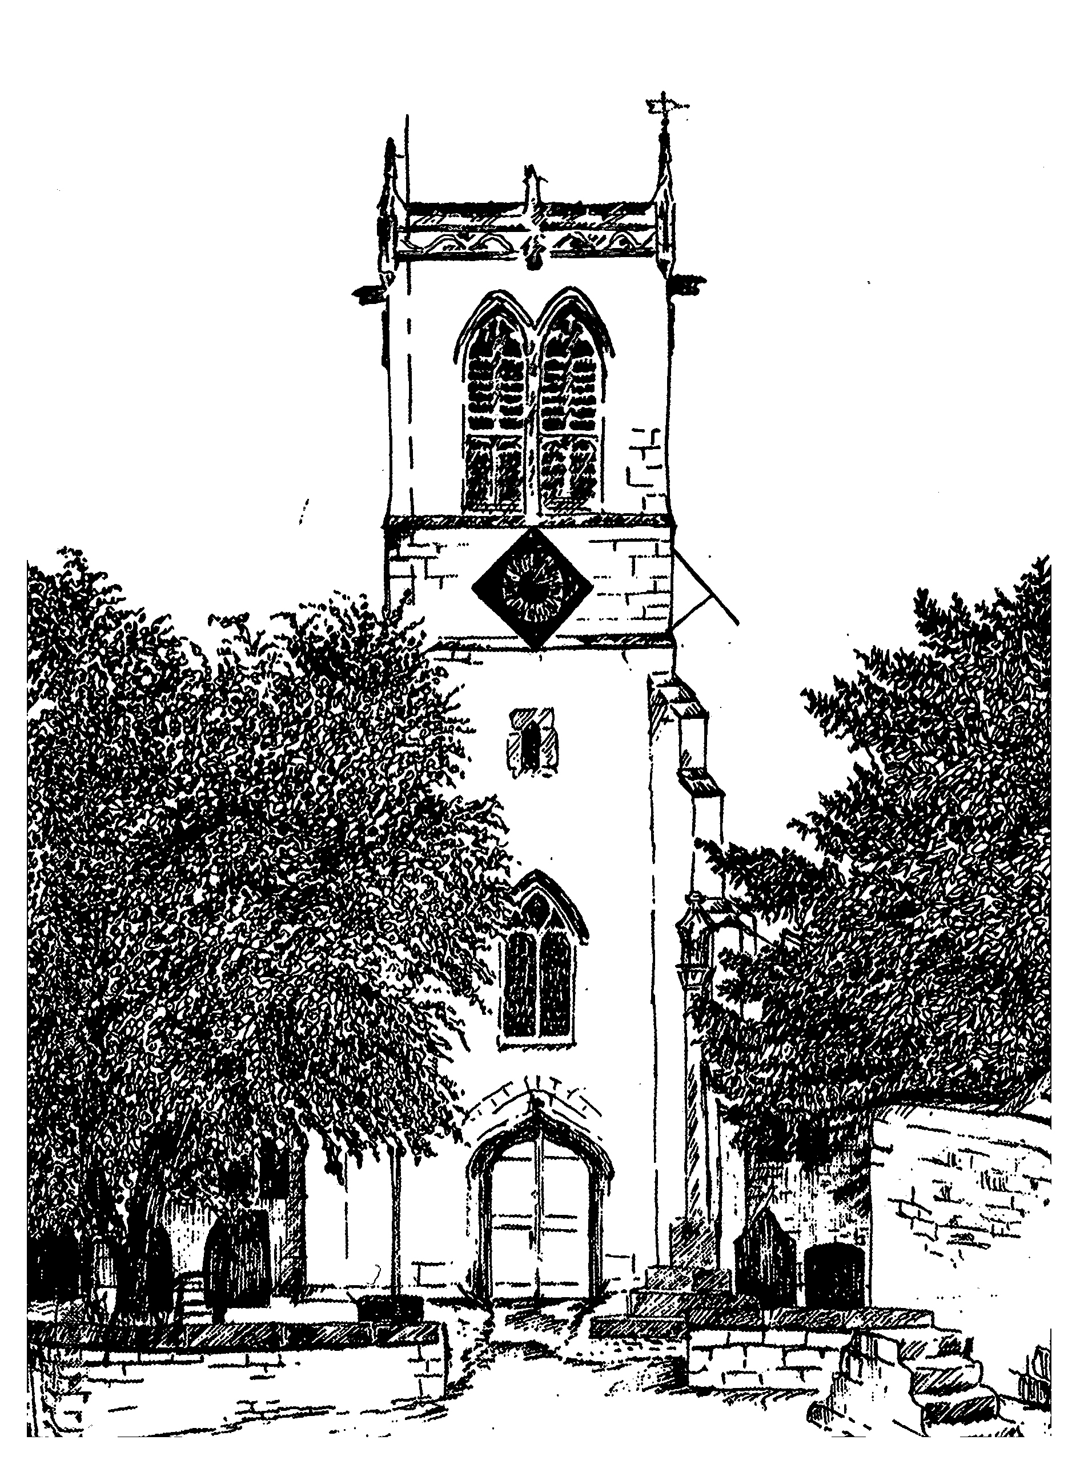
SAFEGUARDING CHILDREN

Parish of St Mary the Virgin Sprotbrough

Statement of Aims

Our aims are:
- To help young people in their Christian discipleship through a programme of learning and thereby to deepen their Christian faith
- To enable young people to experience the love of God
- To encourage a strong Christian fellowship
- Help young people realise their full potential physically, mentally, emotionally and spiritually
- To encourage young people to take a full part in the Church’s life and worship
- To provide a safe meeting place for young people
- To encourage young people to become responsible adults
- To provide indoor and outdoor leisure activities for young people
- To promote equality of opportunity for all

This document covers the work of this parish with children and young people, in its services and in the groups meeting throughout the week.

Currently these groups are:
- T-Time 0-11 years (1st and 3rd Sundays, 4-5pm, Church Hall)
- All-Age Worship (2nd Sunday 10.15am)
- Activity mornings for children (occasional – roughly quarterly)
- Starting Rite – 5 sessions for adults and babies

This policy also covers any work undertaken outside of the church buildings carried out under the auspices of the P.C.C.
- Open the Book
- School Assemblies

Policy Statement
This P.C.C. adopts the policy statement of the Diocese and has it displayed prominently in all church premises. The P.C.C. expects all church workers to follow its Safeguarding Children Policy and Guidelines which are displayed in a prominent place.

Application of the Policy
All new workers, whether paid or voluntary, working for church-based organisations, will be informed of the policy by the Rector, the Safeguarding Children representative or the group leader. All children’s workers will be expected to accept the policy and guidelines and work according to their requirements.
All new members of the P.C.C. will be required to accept the policy and guidelines. The P.C.C. will appoint a group to oversee the policy and guidelines, and they will be placed on the Agenda of the P.C.C. at least annually for review.
The P.C.C. will appoint a Safeguarding Children Representative and will inform the diocesan office of their details.

Church Premises
Any organisation booking the use of church premises will be informed of the need to observe the Policy via a statement on the Booking Form. They should be expected to confirm they have a Safeguarding Children policy and appropriate insurance. Individuals booking church premises for private functions will have the policy drawn to their attention and accept their responsibility for protecting children at that function.

Recruitment
The P.C.C. will follow the recruitment process included in the Safeguarding Children Policy. References, the Confidential Declaration and a DBS disclosure via the Diocesan system will be obtained. Appointment to any post, paid or voluntary, will not be made until these processes are complete. All appointments will be made on a conditional basis until the completion of a satisfactory probationary period. All those working with children and young people will follow the good practice guidelines in the Diocesan Safeguarding Children Policy and Guidelines.

Registration and Parental Consent
All groups will keep a register of those attending each session. Parental consent forms, including emergency contact details, must be completed for all participants, and must be available to group leaders whenever the group meets. This applies to all groups, whether meeting on church premises or elsewhere.
Parental consent to photographs and videos must be obtained, using the consent form and principles in the diocesan guidelines.

Insurance
The P.C.C. will ensure that there is adequate insurance cover for all activities involving children and young people.

Fire Regulations and Security
All group leaders will be aware of fire regulations and the positions of fire extinguishers. They will be vigilant as to the presence of anyone on the premises during the meetings of the groups. They should know who to contact in an emergency relating to the building.

Food and Hygiene
If any group is involved in the preparation or selling of food, at least one leader should have completed the food hygiene and food safety course to ensure good practice is followed.

First Aid and Accidents
Each group should have at least one adult present who has attended a basic course on first aid. There should be a properly stocked first aid kit accessible to each group. In the event of any accident, an incident and accident report form should be completed. This should be kept securely in a marked file. Parents should also be informed of any accident.

Providing an Independent Person
Children and young people should have the opportunity to raise any concerns about any health and safety or safeguarding matters. A notice will be placed on the noticeboard and/or entrance to church and to all church premises with the name of the parish Safeguarding Children Representative/Officer, Childline telephone number and of any other independent person the parish appoints to afford this opportunity.

Allegations
If an allegation is received concerning the behaviour of an adult, the diocesan Allegations Policy (a copy of which can be found in the Safeguarding Children Policy) will be followed.

Concerns About or Reported by a Child
This parish will follow the Diocesan Guidelines and report the concern to the Diocesan Safeguarding Adviser, or to the appropriate Archdeacon. In an emergency or if the child is at immediate risk the appropriate statutory agencies will be informed. All such concerns or incidents should be recorded and kept in a confidential place.

Review
All children and young people’s workers will meet to review their work on at least an annual basis. This should include a review of safeguarding issues and health and safety issues relating to each group. Notification of this meeting should be reported to the P.C.C. The parish Safeguarding Children Representative/Officer will review the parish policy annually and report to the P.C.C., who will record this review in their minutes. The P.C.C. will inform the Archdeacon via the visitation that this has been done. A copy of the current Parish Safeguarding Policy should be sent to the Archdeacon for inclusion in the parish file. A further copy should be sent if there are substantial amendments.

Training
Group leaders will be encouraged to attend the Safeguarding training provided by the Diocese. The parish will consider its training needs at the time it reviews the Safeguarding Policy. If specific needs are identified the parish will consult with the Diocesan Safeguarding Adviser to arrange a training event for the parish or group of parishes in the Deanery.

Use of Social Media

All those using social media, text messaging and e-mail to communicate with children and young people must follow the diocesan guidelines.

Reviewed and readopted July 2018
Due for review July 2019

